Exploring AI

- AI Used : Ideogram
Prompt:
A cute Dog wearing prince dress and the crown at the palace eating great dinner.
Response:
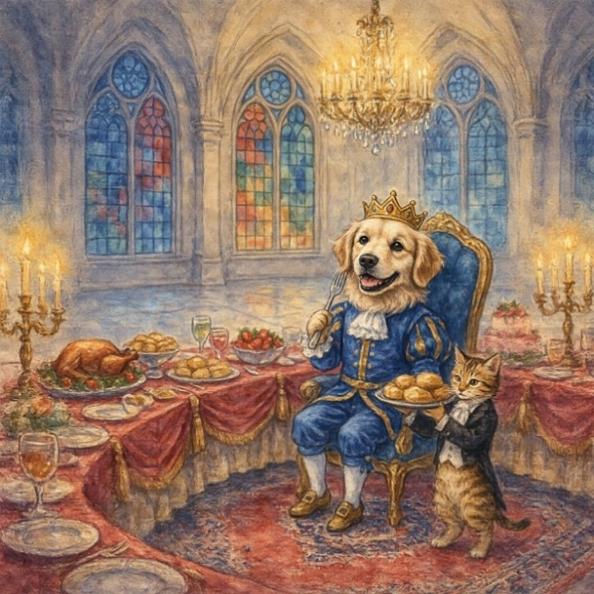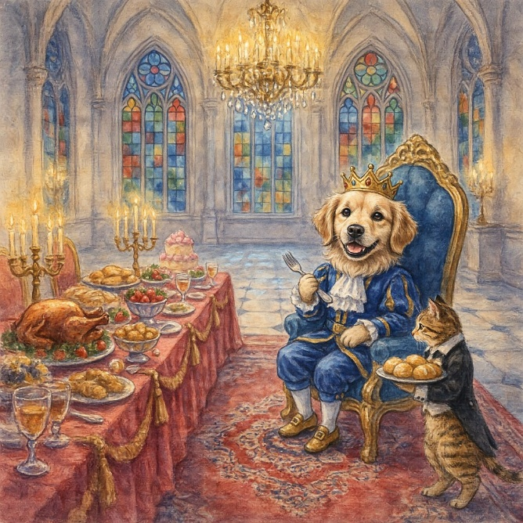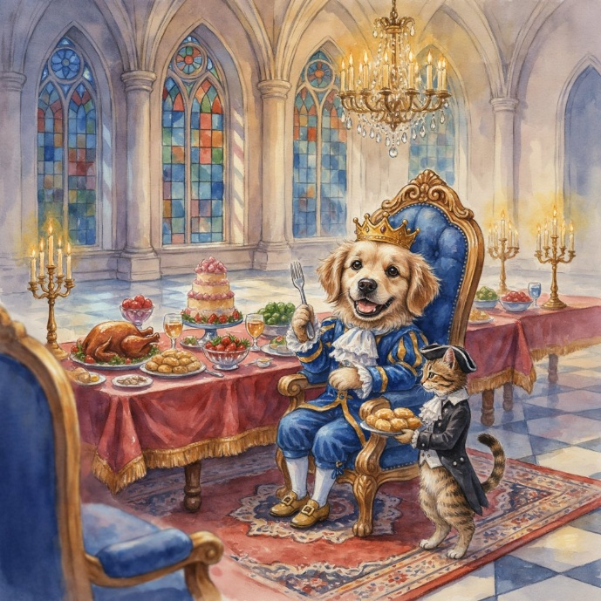

- AI used : Meshy AI
Prompt:
A cute girl wearing a simple maroon lehenga with floral design,standing at the top of the huge mountain,holding her teddy bear in her right hand,make the background as the cloudy climate.
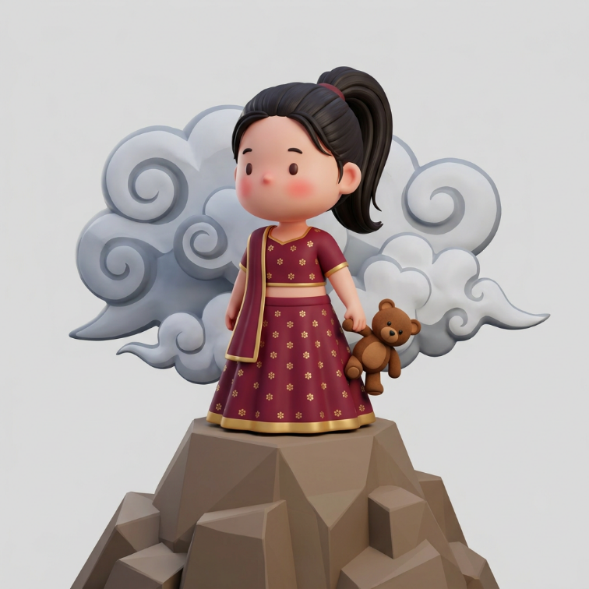
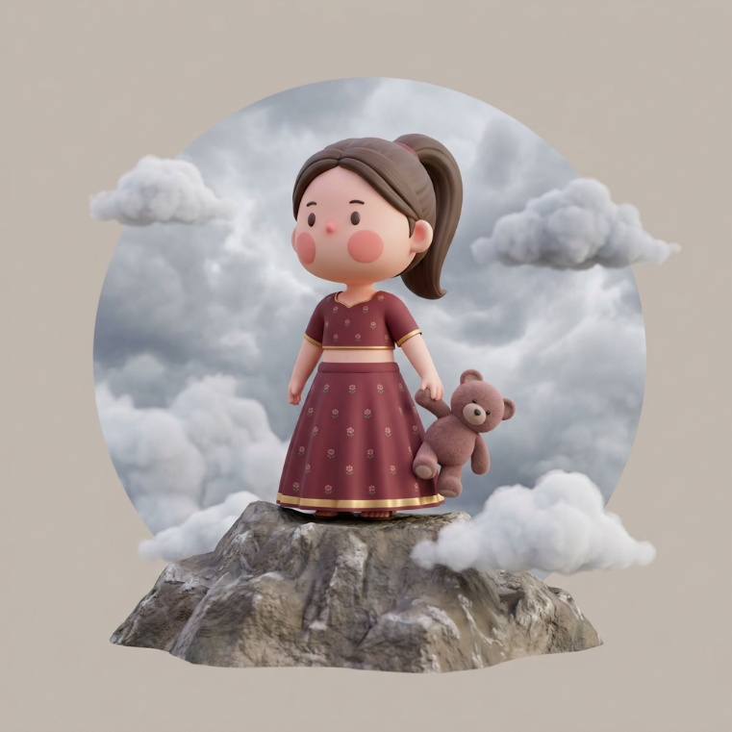

- AI used : OpenArt
Prompt:
A flight landing under water smoothly.

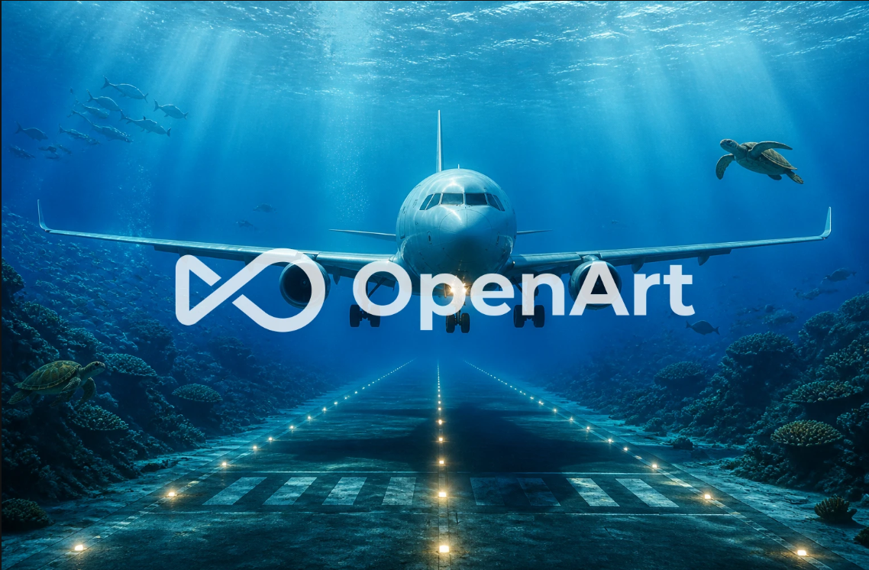

Conclusion:
Through this AI exploration, I explored and experimented with different Generative AI tools such as Ideogram, Meshy AI, and OpenArt, which helped me understand how AI can be used for image generation, 3D model creation, and creative content generation. I also came to know about other AI tools like Meetily, Voicebox, and Midjourney, and learned about their different applications and capabilities.

By giving similar prompts to different AI tools and comparing their responses, I observed that each tool produces different results depending on its model, training, and purpose. This exploration helped me understand the strengths, limitations, and unique features of various AI applications and improved my knowledge of how to select the right AI tool for different tasks.

